|  |  |
| --- | --- |
| Technical note | HaskoningDHV Nederland B.V.  Maritime & Aviation |
| To: | KG DMA |
| From: | Koos Toebes |
| Date: | 13 June 2019 |
| Copy: |  |
| Our reference: | BZ1109-RHD-ZZ-XX-NT-Z-0001 |
| Classification: | Internal use only |
|  |  |
| Subject: | Basis of Simulations - Template |
|  |  |

# Introduction

Shell Global Solutions International B.V has assigned Royal HaskoningDHV (RHDHV) to execute BLNG drift study .

**Current situation**

During inspection of the Marine Loading Arms (MLA) of BLNG it was found that the ESD2 valve closes for some arms within more seconds than the 7s as prescribed in Shell DEPs. The Emergency Shutdown (ESD) is a two-step shutdown approach initiated when the vessel manifold moves out of the safe working envelope of the MLA, with longer closure time it might be possible that the valves are not close when the MLA is disconnected and could result in a spill.

**Desired situation**

**Main question**

The main question that Shell Global Solutions International B.V wants Royal HaskoningDHV to answer is: if safe (off)loading at BLNG with longer ESD2 closure time(10s) still acceptable?

**Purpose of this technical note**

As described in our proposal [REF4], an important part of our approach to answer this main question is the performance of a Dynamic Mooring Analysis (DMA). This technical note (Basis of Simulations, BoS) describes the input for the DMA. After approval of this BoS, we will start with the actual DMA simulations.

**Reading guide**

This Basis of Simulations contains the following sections:

* Section 2 describes the characteristics of the moored vessel, the mooring lines and fenders, together with the mooring arrangement that will be used in the DMA simulations;
* Section 3 presents the environmental conditions at the project location, together with the conditions that are selected for the DMA simulations;
* Section 4 presents the mooring criteria for safe operations and safe mooring against which the runs are being compared.

# Mooring setup

This section describes the characteristics of the moored vessel, the mooring lines and fenders, together with the mooring arrangement that will be used in the DMA simulations.

## Vessel characteristics

>Describe here:

* The vessel that will be used in this DMA study is ~~~ the vessel main dimensions and characteristics are summarized in Table 2-1 [REF ?]
* If windage area also included in Q88 DB? The windage areas from Optimoor seems wrong

Table 2‑1: Main vessel dimensions [REF?]

|  |  |  |  |  |
| --- | --- | --- | --- | --- |
| Description | Symbol | Unit | Value | |
| Spirit of Hela | Spirit of Hela |
| Ballasted | Loaded |
| Deadweight | DWT | t | >enter DWT< | >enter DWT< |
| Displacement | ∇ | t | >enter ∇< | >enter ∇< |
| Length over all | LOA | m |  |  |
| Length between perpendiculars | LPP | m | 285 | 285 |
| Breadth | B | m | 46 | 46 |
| Depth | D | m | 26.8 | 26.8 |
| Draught | T | m | 9.7 | 11.9 |
| Lateral wind area | AL | m2 | 7454 | 2580 |
| Frontal wind area | AF | m2 | 1617 | 830 |

In order to dertermine the location of fairleads and winches, deck plans from Significant Ships of vessels having similar dimensions, have been consulted [>enter REF of Significant Ships<]. The chosen wind areas are based on the cross sections of these similar vessels, which are also provided by Significant Ships. The used deck plan(s) and cross sections can be found in the appendices >refer to appendices<.

The total number of mooring cases is two (as defined in our proposal) [REF4]: one vessel, and per vessel: two loading conditions, one mooring arrangement, one location , and >enter number of set(s) of environmental conditions< set(s) of environmental conditions.

## Line characteristics

>Describe here:

* The mooring lines that will be used in the simulation;
  + Indicate the line material(s) (e.g. steel wire, nylon etc.);
  + Explain why this/these line material(s) has/have been chosen;
  + Refer to source if applicable (e.g. drawings, tables, correspondence etc.);
  + Refer to below table summarizing the line characteristics.<

NOTE: EXTRA COLUMNS (e.g. FOR TAIL OR ADDITIONAL LINE TYPES) CAN BE ADDED IF REQUIRED (RIGHT MOUSE CLICK 🡪 INSERT).

* The mooring lines that will be used in the simulation:
  + In this DMA study, the new Steel Wire ropes & 22m/11m (springs only) Nylon pennants will be used as mooring lines
  + The mooring line characteristics are summarized in Table 2-2

Table 2‑2: Mooring line characteristics.

|  |  |  |  |
| --- | --- | --- | --- |
| Description | Unit | Line | Tail |
| Material | - | Steel wire | Nylon |
| Diameter | mm | 42 | 87 |
| Length | M | ~ | 11/22 |
| Ship design Minimum Breaking Load (Ship design MBL) | kN | 75,000 | 75,000 |
| Working Load Limit (WLL) | kN | 125,000 | 171,000 |

The load elongation curves are based on OCIMF MEG4 [REF2], refer to [Figure2-1]. Further note that:

* The pretension is assumed to be > Not be determined yet, 15t from Optimoor<% of the Ship design MBL for all lines;
* The pretension is assumed to be 15 tone for all the mooring lines;
* The load-elongation curves are calculated separately for each individual line length;

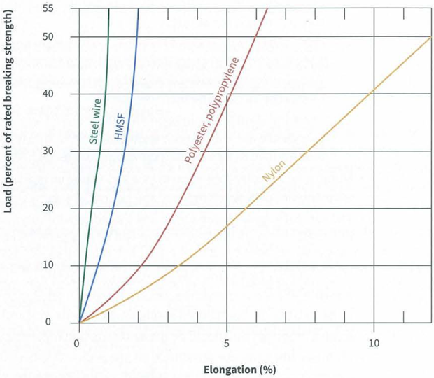Figure 2‑1: Load-extension characteristics.

## Fender characteristics

>Describe here:

* The fender(s) that will be used in the simulation;
  + Indicate the manufacturer (e.g. Yokohama, Trelleborg etc.);
  + Indicate the type of fender(s) (e.g. cone fender, floating fender etc.);
  + Explain why this/these fender(s) has/have been chosen;
  + Refer to source if applicable (e.g. drawings, tables, correspondence etc.);
  + Refer to below table summarizing the fender characteristics;
  + Insert and refer to figure showing the load deflection curve.<

NOTE: EXTRA COLUMNS (e.g. FOR ADDITIONAL FENDER TYPES) CAN BE ADDED IF REQUIRED (RIGHT MOUSE CLICK 🡪 INSERT).

Table 2‑3: Fender characteristics.

|  |  |  |
| --- | --- | --- |
| Description | Unit | >enter fender type< |
| Height / diameter | m | >enter height / diameter< |
| Number | - | >enter number of fenders< |
| Energy absorption capacity | kNm | > enter energy< |
| Reaction force | kN | >enter reaction force< |
| Fender friction | - | >enter fender friction< |

The modelled fender friction is >enter fender friction (by default 0.1)< By choosing a low fender friction, more conservative results are found (large friction would dampen out the surge motion response).

## Mooring arrangement

>Describe here:

* The mooring arrangement that will be used;
  + Explain why this mooring arrangement has been chosen (Based on expert judgement? Based on OCIMF guidelines? As proposed by Client? Etc.);
  + Refer to source if applicable (e.g. drawings, tables, correspondence etc.);
  + Insert and refer to figure in this note showing the mooring arrangement. This figure should also show (top view and front/back view):
    - Location (x, y and z) and spacing bollards;

Location (x, y and z) and spacing fenders<

As approved by Shell Global Solutions International B.V, the mooring layout used in Optimoor report [REF6] will be deployed in this DMA study, Figure2-2 shows this mooring layout.

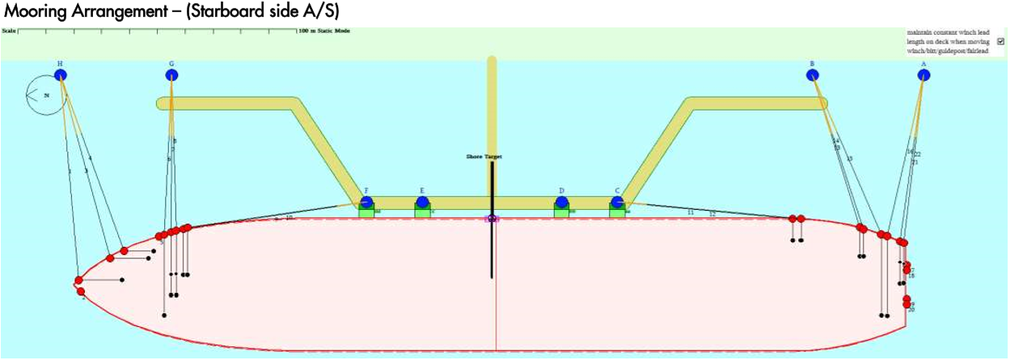

Figure 2-2, Mooring layout [REF6]

Insert equivalent RHDHV drawings, plan view, side view..

## Number of mooring cases

The total number of mooring cases is >enter number of mooring cases< (as defined in our proposal) [>enter REF to proposal<]: >enter number of vessel(s)< vessel(s), and per vessel: >enter number of loading conditions< loading condition(s), >enter number of mooring arrangement(s)< mooring arrangement(s), >enter number of location(s)< location(s), and >enter number of set(s) of environmental conditions< set(s) of environmental conditions.

# Environmental conditions

This section presents the environmental conditions at the project location, together with the conditions that are selected for the DMA simulations.

## Water level and water depth

>Describe here:

* The water level that will be used in the simulations:
  + Provide water level in meters with respect to reference level (e.g. Chart Datum);
  + Explain why this water level has been chosen (conservative choice? As proposed by Client? Etc.);
  + Refer to source if applicable (e.g. drawings, tables, correspondence etc.).
* The water depth that will be used in the simulations:
  + Provide bed level in meters with respect to reference level (e.g. Chart Datum);
  + Refer to source if applicable (e.g. drawings, tables, correspondence etc.).<

## Wind conditions

>Describe here:

* The wind conditions at the project location;
  + Explain on which (hindcast) data set the statistical wind data has been based on;
  + Refer to source if applicable (e.g. drawings, tables, correspondence etc.);
  + Explain the distribution of wind directions. What are dominant directions?;
  + Explain the distribution of wind speeds;
  + Mention the wind spectrum that will be applied;
  + Insert and refer to figure showing the distribution of the wind directions (e.g. wind rose);
  + Insert and refer to figure showing the distribution of the wind speeds (e.g. wind rose).<

## Wave conditions

>Describe here:

* The wave conditions at the project location;
  + Explain on which (hindcast) data set the statistical wave data has been based on;
  + Refer to source if applicable (e.g. drawings, tables, correspondence etc.);
  + Explain the distribution of wave heights;
  + Explain the distribution of wave periods;
  + Explain the distribution of wave directions. What are dominant directions?;
  + Insert and refer to figure showing the distribution of the wave heights (e.g. wave rose);
  + Insert and refer to figure showing the distribution of the wave periods (e.g. wave rose);
  + Insert and refer to figure showing the distribution of the wave directions (e.g. wave rose).<

## Current conditions

>Describe here:

* The current conditions at the project location;
  + Explain on which (hindcast) data set the statistical current data has been based on;
  + Refer to source if applicable (e.g. drawings, tables, correspondence etc.);
  + Explain the distribution of current directions. What are dominant directions?;
  + Explain the distribution of current speeds;
  + Insert and refer to figure showing the distribution of the current directions (e.g. current rose);
  + Insert and refer to figure showing the distribution of the current speeds (e.g. current rose).<

## Selected environmental conditions

With the abovementioned wind and current conditions, the mooring case will be simulated as follows:

**Selected wind conditions**

* >enter number of wind directions< wind directions:
  + From >enter wind direction in degrees<° to >enter wind direction in degrees<°;
  + Wind directional interval of >enter wind directional interval in degrees<°.
* >enter number of wind speeds< wind speeds:
  + From >enter wind speed in meters per second< m/s to >enter wind speed in meters per second< m/s;
  + Wind speed interval of >enter wind speed interval in meters per second< m/s.
* >enter wind spectrum< wind gust spectrum.

**Selected wave conditions**

* >enter number of wave directions< wave directions:
  + From >enter wave direction in degrees<° to >enter wave direction in degrees<°;
  + Wave direction interval of >enter wave direction interval in degrees<°.
* >enter number of wave heights< wave heights:
  + From >enter wave height in meters< m to >enter wave height in meters< m;
  + Wave height interval of >enter wave height interval in meters< m.
* >enter number of wave periods< wave periods:
  + From >enter wave period in seconds< s to >enter wave period in seconds< s;
  + Wave period interval of >enter wave period interval in seconds< s.

**Selected current conditions**

* >enter number of current directions< current directions:
  + From >enter current direction in degrees<° to>enter current direction in degrees<°;
  + Current direction interval of >enter current direction interval in degrees<°.
* >enter number of current speeds< current speeds:
  + From >enter current speed in meters per second< m/s to >enter current speed in meters per second< m/s;
  + Current speed interval of >enter current speed interval in meters per second< m/s.

This yields a total number of >enter total number of simulations< simulations.

# Mooring criteria

There is a distinction between safe operations (ship motions exceed criteria) and safe mooring (mooring line forces exceed criteria). This section presents the mooring criteria for safe operations and safe mooring against which the runs are being compared.

## Acceptable vessel motions

The maximum allowable vessel motions are based on PIANC [>enter REF PIANC<]. If the vessel motions exceed (one of) these motion criteria, loading and/or offloading is not possible (unsafe operation). The motion criteria can be found in >include cross reference to table<.

NOTE: in the table below, the rows of irrelevant commodities can be deleted. First delete the content in the cells of a whole row. Then the row can be deleted.

Table 4‑1: Acceptable vessel motions.

|  |  |  |  |  |  |  |  |
| --- | --- | --- | --- | --- | --- | --- | --- |
| Vessel type | Cargo handling equipment | Surge [m] | Sway [m] | Heave [m] | Yaw [°] | Pitch [°] | Roll [°] |
| Fishing vessel | * Elevator crane * Lift-on-lift-off * Suction pump | 0.15  1.0  2.0 | 0.15  1.0  1.0 | 0.4 | 3  3  3 | 3  3  3 | 3  3  3 |
| Freighter, coaster | * Ship’s gear * Quarry cranes | 1.0  1.0 | 1.2  1.2 | 0.6  0.8 | 1  2 | 1  1 | 2  3 |
| Ferrie, Ro-Ro | * Side ramp * Dew/storm ramp * Linkspan * Rail ramp | 0.6  0.8  0.4  0.1 | 0.6  0.6  0.6  0.1 | 0.6  0.8  0.8  0.4 | 1  1  3 | 1  1  2  1 | 2  4  4  1 |
| General cargo |  | 2.0 | 1.5 | 1.0 | 3 | 2 | 5 |
| Container vessel | * 100% efficiency * 50% efficiency | 1.0  2.0 | 0.6  1.2 | 0.8  1.2 | 1  1.5 | 1  2 | 3  6 |
| Bulk carrier | * Cranes * Elevator / bucket-wheel * Conveyor belt | 2.0  1.0  5.0 | 1.0  0.5  2.5 | 1.0  1.0 | 2  2  3 | 2  2 | 6  2 |
| Oil tanker | * Loading arms | 3.0 | 3.0 | 0.15 |  |  |  |
| Gas tanker | * Loading arms | 2.0 | 2.0 | 1.0 | 2 | 2 | 2 |

For the definition of the different vessel motions, we refer to >include cross reference to table<.

|  |  |  |  |
| --- | --- | --- | --- |
| **Translations** | | **Rotations** | |
| **Surge** |  | **Roll** |  |
| **Sway** |  | **Pitch** |  |
| **Heave** |  | **Yaw** |  |

Figure 4‑1: Terminology of vessel motions.

## Acceptable line forces

The Working Load Limit (WLL) is based on OCIMF MEG4 [>enter REF OCIMF MEG4<] and is >enter percentage of Ship design MBL<% of the Ship design Minimum Breaking Load (Ship design MBL). If the mooring line forces exceed the WLL, the mooring becomes unsafe.

## Acceptable fender forces

The maximum fender deflection, which is provided by the fender manufacturer, is used as a criterion.

In principle the fenders should prevent that the vessel exerts excessive lean-on forces on the dolphins or the quay. Practically this implies that the forces in the fender and fender deflection allowed while moored should not exceed the forces while berthing. The maximum lean on forces on the quay and mooring dolphins could be exceeded when the maximum deflection of the fender is exceeded. Therefore the maximum fender deflection is used as a criterion.

Generally speaking, the fender deflection and fender forces while berthing are most often governing over

the fender forces while being moored. Still, the outcome of the fender forces from the DMA is compared

with the criteria (maximum deflection of the fender should not be exceeded).

Acceptable valves closure time:

The time of LNG moves out of mechanical envelope should over valves design closure time(7s).

# References

Some references that are / can be used are provided below. Please be sure to have the cross references correct and to have the references in the right order.

1. PIANC. Criteria for movements of moored ships in harbours. 1995
2. OCIMF; Mooring Equipment Guidelines 4th edition; 2018
3. Significant Ships of >year<
4. BG8058-RHD-ZZ-XX-Z-0001 BLNG drift study proposal P01
5. SST03763 Optimoor Analysis Spirit of Hela at Lumut LNG